‘Remembering Together’
Join us in remembering our loved ones who have died during the time of the COVID 19 Pandemic
Wednesday 24th March @ 7pm
via Bath Abbey YouTube channel
https://www.youtube.com/channel/UCSTBxSCyS70_S_ZiPd-DANA
This is an On-Line Gathering open to everyone: we will take time as members of the wider and diverse community to pause together, to offer thanks and to celebrate the life of our loved ones.

You are all welcome; those of all faiths and none. We will reach out to one another as an act of unity and understanding from wherever we are.
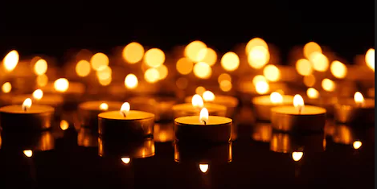

This is a joint offering made by Royal United Hospital Bath, Bath Abbey, affiliated faith communities, Dorothy House Hospice Care and Bath & North East Somerset Care Homes. It also includes a warm invitation to those who live in North Somerset and Wiltshire.

